

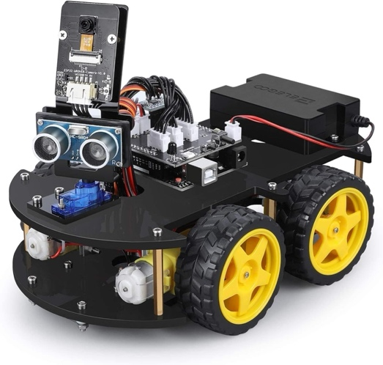

**SEP 780 - ADVANCED ROBOTICS AND AUTOMATION**

Robotics Project Proposal

Professor: Dr. Richard Ma

Winter 2025

Group 6

|  |  |
| --- | --- |
| **Team Members** | **Student IDs** |
| Hongqing Cao | 400053625 |
| Leila Dabbaghzadeh | 400550744 |
| Pengbo Ma | 400592946 |
| Zhengrong Yu | 400609809 |

# Table of Contents

Table of Contents 1

1. Introduction 2

2. Functions 2

2.1 Enhanced Functions 3

2.2 Simulated Environment 3

2.3 Function Table 4

3. Project Timeline and Task Distribution 5

4. Project Risk Assessment 6

4.1 Risk of the equipment (the car itself) 6

4.2 Risk of project management 6

4.3 Risk of using the car in the scenario of this project 7

# 1. Introduction

Nowadays, there are numerous types of robots capable of performing various actions depending on the situation and the specific area in which they are utilized. As technology continues to advance the capabilities of these robots are steadily expanding. In this project, we will utilize the ELEGOO Smart Robot Cat Kit V4.0 to develop a robot capable of achieving our objectives. This kit includes an embedded operating system and offers several modes, such as auto-go, infrared control, obstacle avoidance, and line tracking. These features are valuable for enhancing practical robotics skills and transforming creative ideas into functional designs. Additionally, the kit is well-constructed and comes with detailed documentation, allowing us to thoroughly test the built-in functions before developing additional custom features. This project will involve assembly, programming, testing, function demonstration, and final report writing, with tasks distributed equally among all group members.

The robotic system is outfitted with an advanced color recognition system that enables it to navigate its path towards the designated production line. Upon arrival at the specified location, the robot efficiently loads the produced goods and transports them to a predetermined destination. Additionally, it is capable of rotating 180 degrees to ensure precise positioning during the loading and unloading processes. Furthermore, a physical loading platform has been installed on the robot to facilitate the efficient handling and transportation of goods.

# 2. Functions

The functions of this robot are divided into two categories. The first category comprises a series of basic functions provided by the manufacturer. The basic functions are detailed below:

* **Auto-Follow Mode:** In this mode, the robot moves autonomously following the obstacles within 20cm ahead detected by the ultrasonic sensor. If there’s no obstacle in that range, the robot will adjust sensor position through servo.
* **Infrared Control Mode:** This mode enables the robot to be controlled using an infrared (IR) remote. The IR remote sends signals to the robot's IR receiver, allowing the user to manually control the robot's movements, such as moving forward, backward, and turning left or right.
* **Obstacle Avoidance Mode:** The robot uses sensors to detect obstacles in its path and automatically adjusts its movements to avoid collisions. This mode is particularly useful for navigating through environments with unpredictable obstacles.
* **Line Tracking Mode:** Line tracking allows the robot to follow a predefined path marked by a line on the ground. The robot uses sensors to detect the line and adjusts its movements to stay on course, making it ideal for applications that require precise path following.

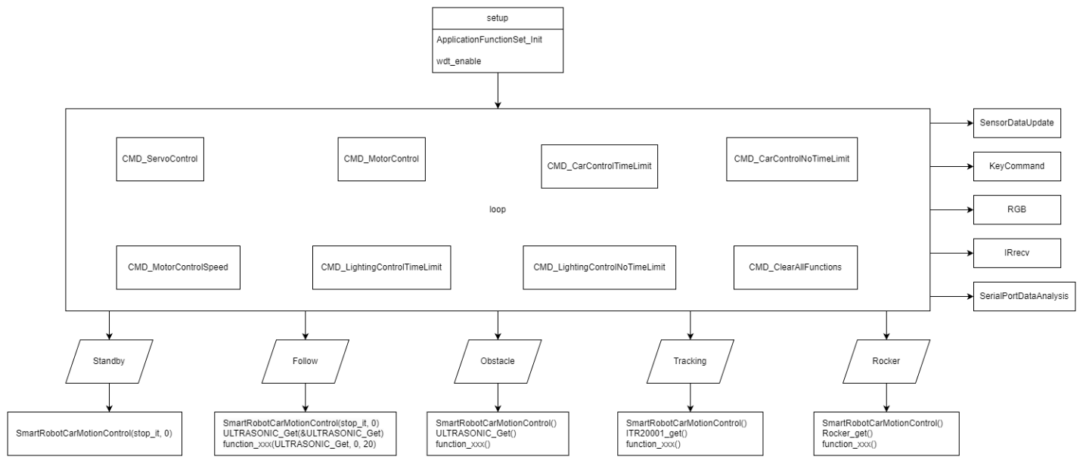

## 2.1 Enhanced Functions

Our team is working on implementing additional features on this kit.

* **Color Recognition:** Developing a new feature that enables the robot to recognize different colors using a camera, allowing it to continue its path based on color detection.
* **Physical Loading Platform:** Installing a physical loading platform on the robot to facilitate the transportation of goods from the production line to a hypothetical stock area.

## 2.2 Simulated Environment

The robot operates between two areas: the production line and the packaging line. A line on the ground maps the route connecting all destinations. In front of the packaging line, a colored lighting signal indicates which production line is ready for loading.

Hypothetical Scenario:

1. Standby Mode – The robot remains idle at the packaging line while the signal is red and the loading platform is empty.
2. Loading Signal – The signal turns green, indicating that Production Line 1 is ready for loading.
3. Transit to Production Line – The robot follows the line-tracking route to Production Line 1.
4. Loading – The robot waits for a designated loading time period.
5. Return – The robot moves back to the packaging line.
6. Unloading – The robot waits for another designated unloading time period.
7. Standby Mode – The cycle resets, and the robot remains in standby until the next signal.

|  |  |  |  |
| --- | --- | --- | --- |
| Robot State | Color Signal | Loading Platform | Action |
| Standby Mode | Red | Empty | Wait at the packaging line |
| Loading Signal | Green | Empty | Detect signal |
| Transit to Production Line | Off | Empty | Move via line-tracking |
| Loading | Off | Loading | Wait for loading time |
| Return | Off | Loaded | Move via line-tracking |
| Unloading | Off | Unloading | Wait for unloading time |
| Standby Mode | Red | Empty | Wait at the packaging line |

The relationship between color signal and facility status is showing below:

|  |  |  |
| --- | --- | --- |
| Color Signal | Production Line | Packaging line |
| Red | All production lines are running | Occupied |
| Green | Production line 1 is ready to load | Empty |
| Blue | Production line 2 is ready to load | Empty |
| Yellow | Production line 3 is ready to load | Empty |

## 2.3 Function Table

|  |  |  |  |
| --- | --- | --- | --- |
| Function | Original Aurthor | In project Implementation | Technical Parts and Libraries |
| Auto-Following Mode | Elegoo | Dropped | Motor, Ultrasonic sensor, Servo |
| Infrared Control Mode | Elegoo | Kept as back-up | Motor, IR Module |
| Obstacle Avoidance Mode | Elegoo | Dropped | Motor, Ultrasonic sensor |
| Line Tracking Mode | Elegoo | Enhanced with mapped route | Motor, Line-tracking Module |
| Camera | Elegoo | Modified to meet projecct scope | Camera Module |
| Color Recognition | Our team | Developed from scratch | Camera Module, OpenCV |
| Physical Loading Platform | Our team | Simulated manually | N/A |

# 3. Project Timeline and Task Distribution

The One-Page Project Management (OPPM) chart below presents a detailed timeline, outlining the major tasks and subtasks that the team must complete throughout the project period. The table below lists all tasks and subtasks that the team aims to complete, based on the OPPM provided in the previous section. Tasks are assigned to each member according to their individual strengths to ensure equal contribution and active participation in the project.

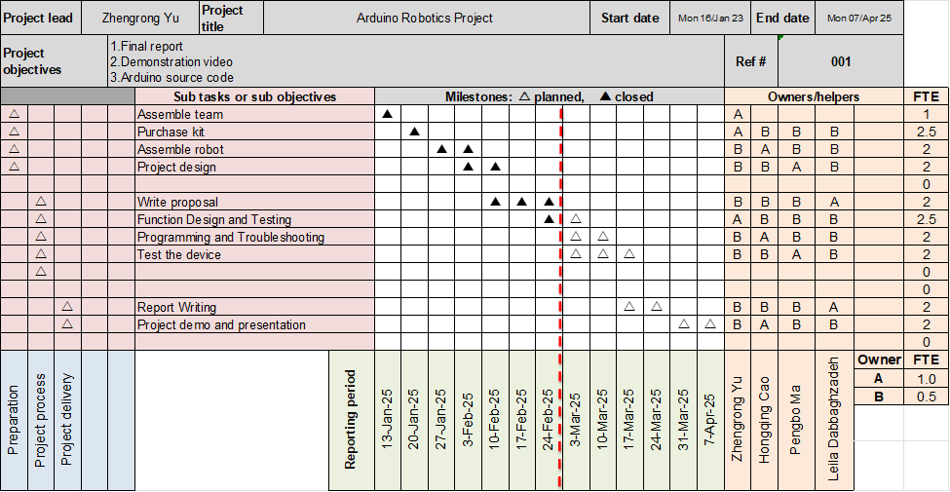

# 4. Project Risk Assessment

## 4.1 Risk of the equipment (the car itself)

* Failures in the components of the robot car, such as motors, sensors, and cameras, can affect the normal operation of the car.
* Problems with wiring when assembling the car, loose or incorrect wiring when connecting peripherals can cause failures.
* The motor will overheat when working, affecting the operation of the car.
* Errors in the code that controls the operation of the car and implements various functions.
* In low-light conditions, the camera has difficulty capturing.
* Signal interference problem when the car is running.

## 4.2 Risk of project management

* Underestimating the time needed for debugging and improvement.
* Extreme weather can affect project progress.
* Replacing parts or adding equipment will incur additional expenses.
* Some team members may have reasons to be absent from project meetings, affecting project progress.

## 4.3 Risk of using the car in the scenario of this project

* The overheating problem of the car has a certain impact on the safety of the factory production line.
* The car may have uncontrolled movements, which may cause safety issues for factory workers when using the car.
* When the car runs out of power, it will stop working, affecting the normal operation of the production line and factory.